**7-1 Final Project**

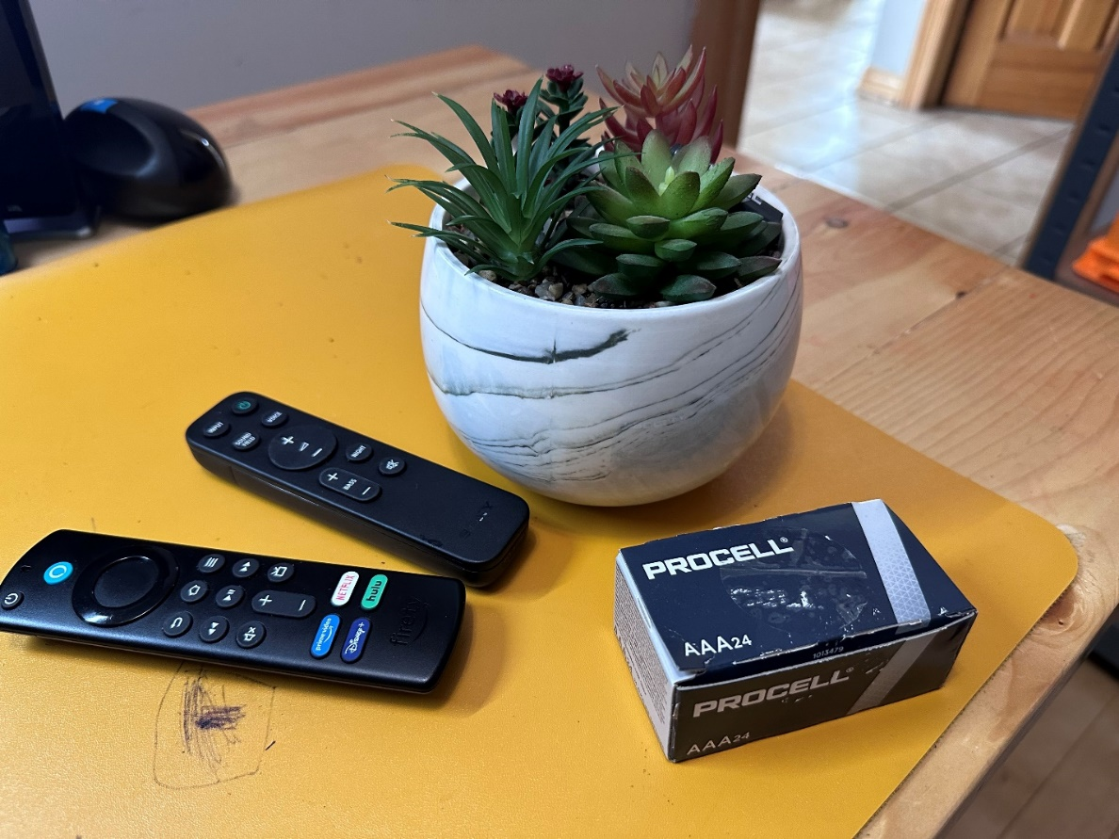

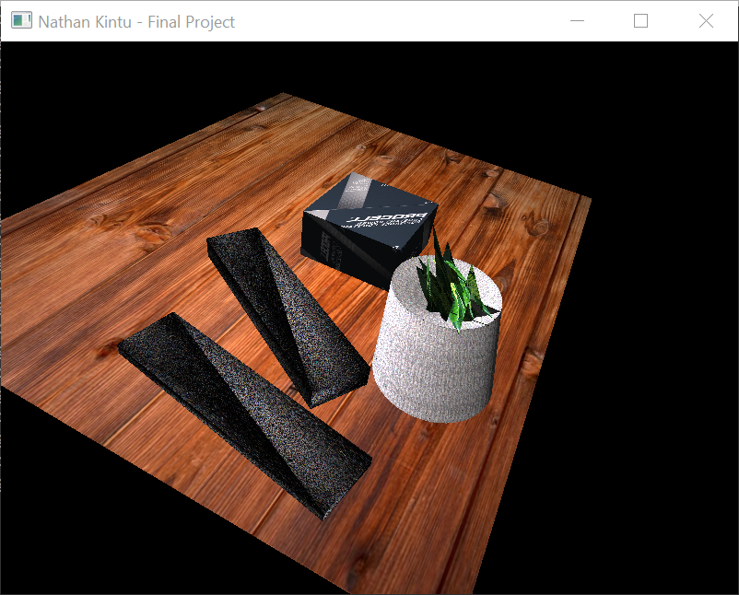

**Final Project.**

My final project includes simple shapes like cubes, a cylinder and irregular objects. I started with a plane to represent the table. To make my project more interesting and attractive, I eliminated the yellow tabletop and displayed a wood grain texture. This first part was the easiest throughout the recreation process.

For the objects in the image, I started with the one at the extreme end which guided me on the proportions of the images on the front or foreground.

Cubes were easier to recreate, and repositioning was mainly using rotation coordinated to move them on the table.

The cylinder which represents the flower vase was the most challenging of all items. Once I figured out how to recreate it, it became easier to determine the radius and the location where I wanted it on the table. The flowers were more fun to recreate. All I did was to position a cube on top of the cylinder and then rearrange the triangles all facing independent directions while maintaining position on top of the cylinder.

Texture was an important aspect of my project. Texture was selected to match the elements in the photo and in my project, it looks so similar depending on the item represented.